**SMART STAR EXAMINATIONS BOARD**

**END OF TERM ONE EXAMINATION - 2024**

**ENGLISH**

**BABY CLASS**

My name is…………………………………………..

END OF TERM I EXAMS **READY IN SOFT COPIES**

**( BABY TO P.6 )**

* **P.7 TESTS ALSO AVAILABLE**
* **HOLIDAY PACKAGES IN SOFT COPIES ALSO AVAILABLE.**
* **LESSON NOTES AND SCHEMES OF WORK**

CONTACT: 0753676594 0782297443

1. **Trace the cup.**

1. **Tell the pictures.**

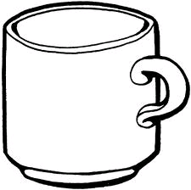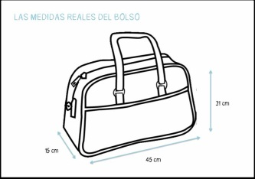

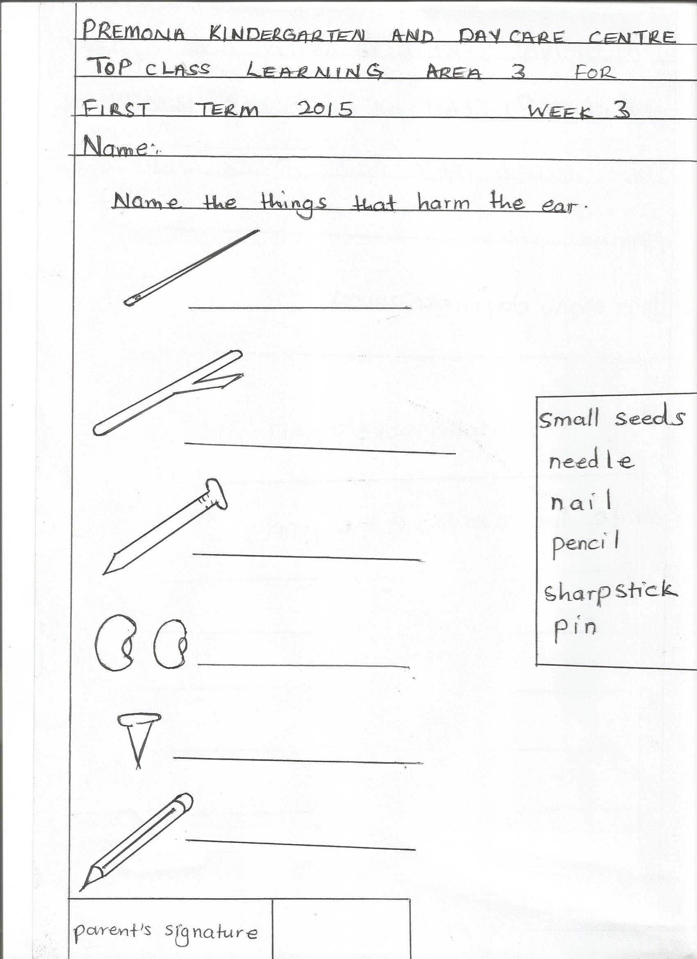

1. **Shade the sun with colour yellow.**

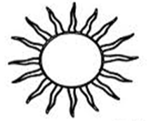

1. **Match the same.**

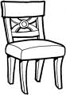

**NICE HOLIDAY**